**LIGHTING AND RENDERING**

**Introduction**

The Olympoid was created to represent Romania in Artistic Gymnastics during the Summer Olympics and in Figure Skating during the Winter Olympics. I tried to incorporate cultural elements in the design by choosing a traditional colour palette: black, red, brown and white, as well as patterns often found on old Romanian clothes. In order to plan ahead, I did a few watercolour sketches of my robot in different poses, to determine which one I liked the best and to experiment with the colours chosen.

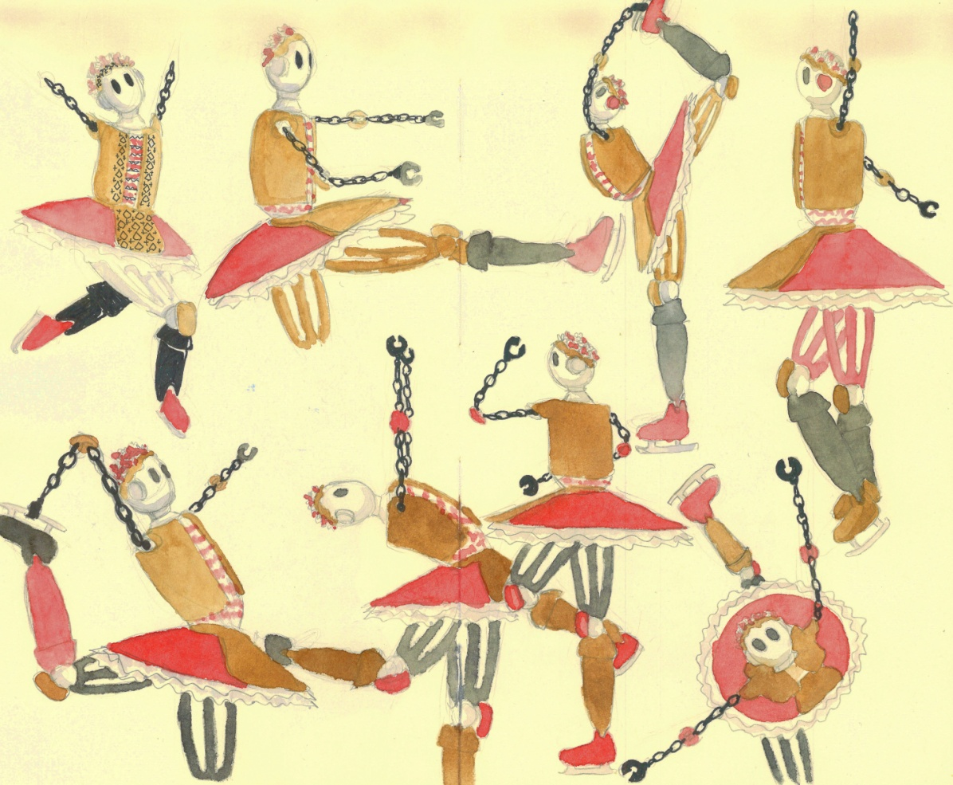

**Challenges and highlights**

I started the process by assigning different materials with the respective colours to the different parts of the Olympoid. This brought to light a flaw in my design, since I needed to assign multiple materials to the same object. For example, the vest and the traditional Romanian blouse, called “ie”, are a single object, even though they are made of different materials. In order to give the right colours to these parts of my robot, I had to select faces and assign a new material to the selection, which is more time consuming than having them as two separate objects. The same issue arose with the skirt and apron, and the head and headdress.

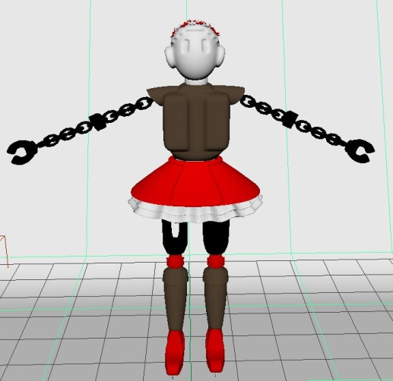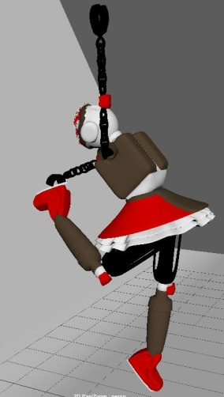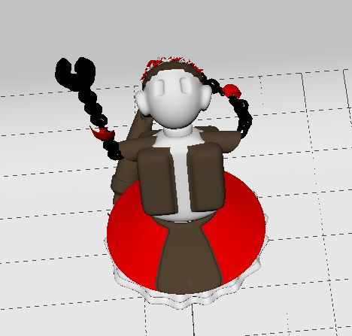

After assigning materials to the robot, I put my Olympoid into the pose I decided based on my sketches. I then started assigning textures to the materials. For the ice blades, I increased the metalness and used noise, then gave the skates a leathery texture. I used the “leather” texture on the bottom layers of the skirt as well, but I increased the cell size, in order to give it a simple pattern without giving the impression that it is made out of leather. Then I increased the metalness of the head, body and legs, since those are the most robotic parts of my design.

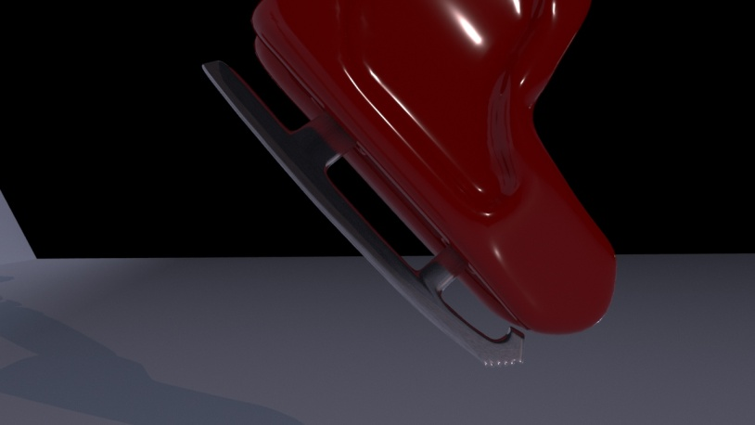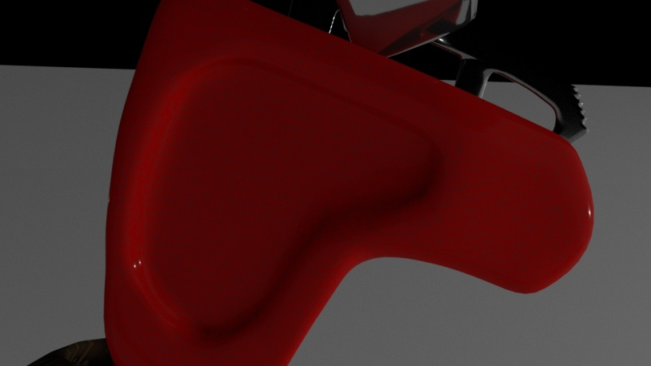 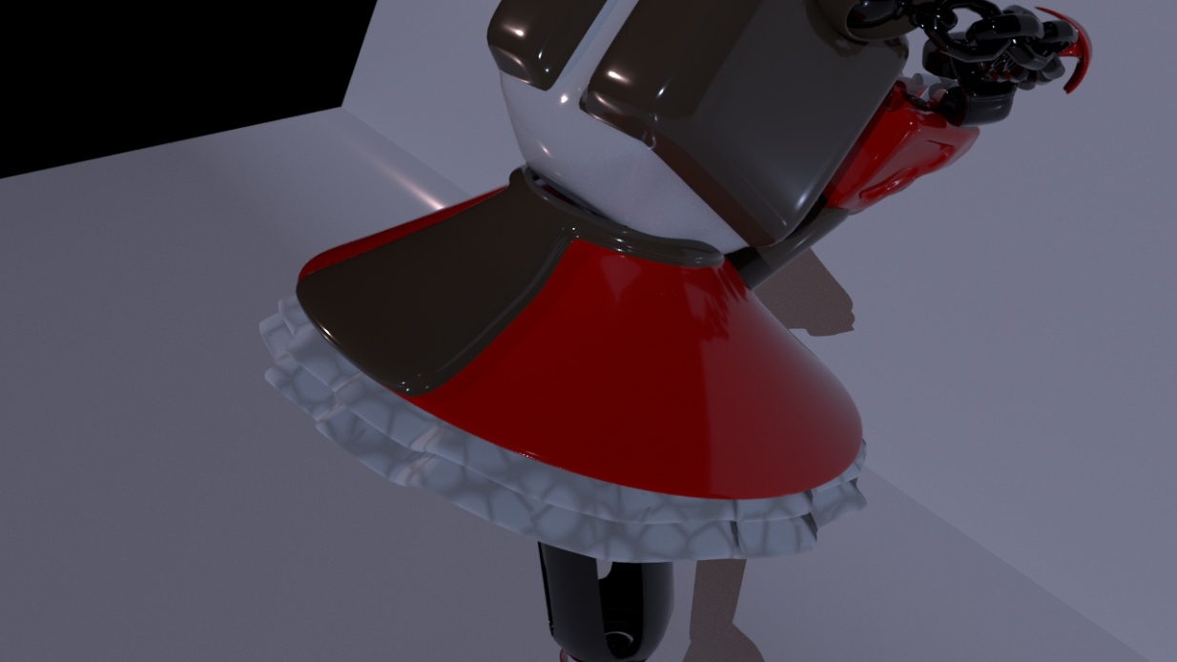

For the socks, I used the “cloth” texture and decrease the specularity, then changed the UV space to “cylindrical”, in order to avoid stretch effects. I used the same texture for the knee and elbow pads, but changed the width in order to get a different pattern and left the specularity high. For the torso, I planed from the beginning of the design to have it resemble the Romanian blouse, “ie”, therefore I used an image with traditional patterns and changed the UV to “spherical” so that it would fit. I also reduced the specularity, but not completely since I wanted it to look robotic, with the patterns printed on top.

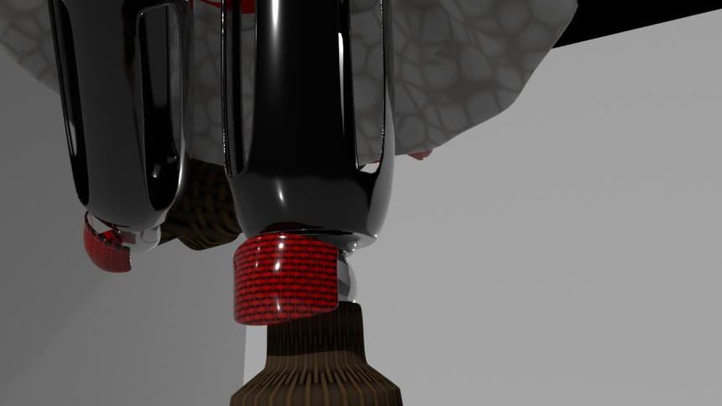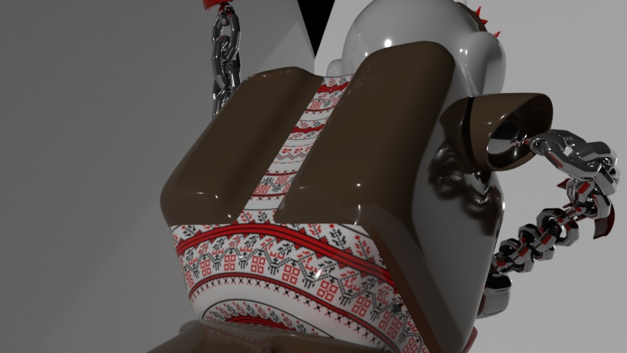

For the vest, I used the “cloth” texture and reduced the specularity. Then I found an image of a Romanian apron from the 19th century that is public domain and used it to create a new material with that pattern. Afterwards, I selected faces on the front of the vest and assigned them the new material, also changing the UV to “planar”. I did the same for the apron, and also used the pattern for the headdress.

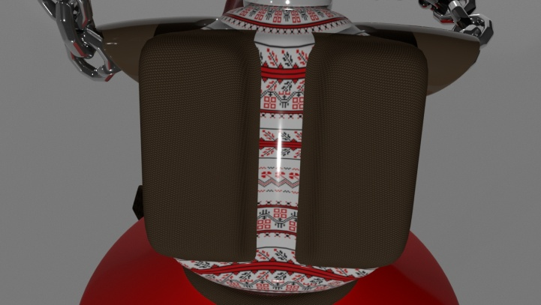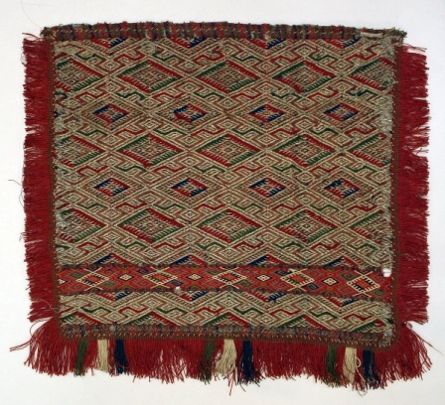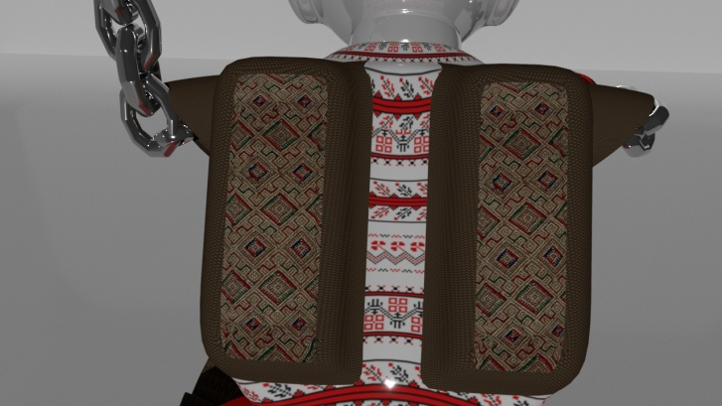

For the arms, I increased the metalness and used the “Brownian” texture. Then, in order to add some interest to the skirt, I found an image of a flower pattern, changed the colour to red and used it as texture. I also decreased the specularity, and then added the pattern to the dent in the skates as well.

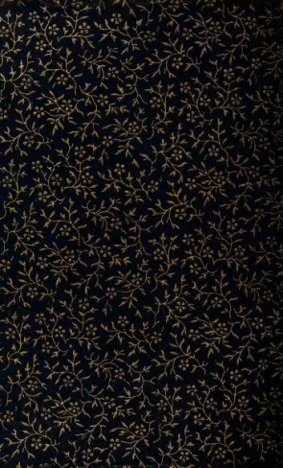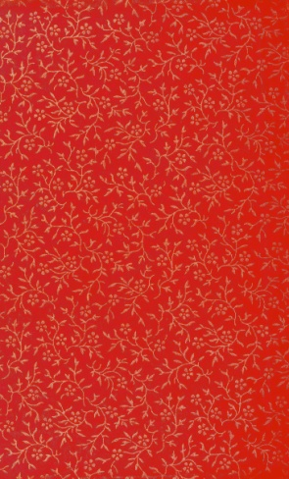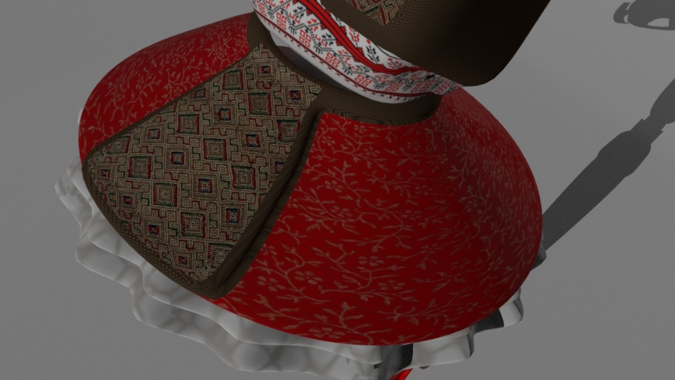

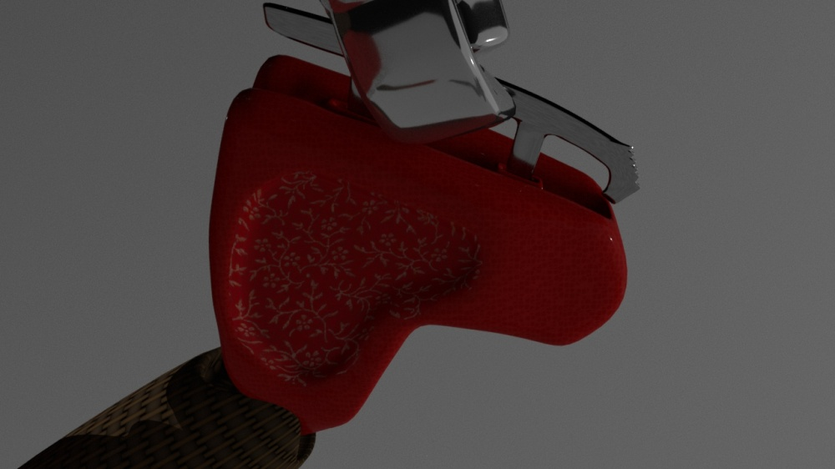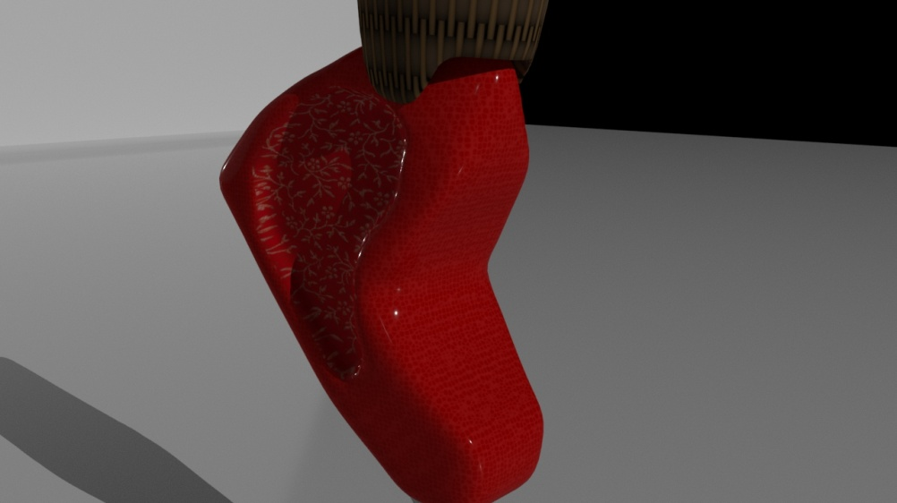

For the environment, since I chosen a camera perspective looking down, I needed to create the impression that the floor is an ice rink. To achieve that, I used an ice texture on the floor plane. I then decided to add flowers around the scene to give the impression of an audience throwing flowers towards the end of a performance.

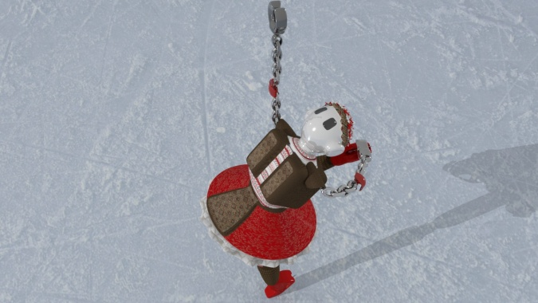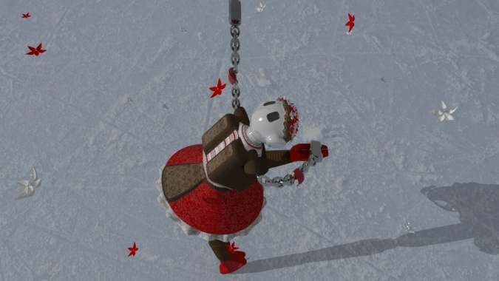

For the lighting, I used directional lights of a cool grey colour and set on a low intensity, and a more intense spotlight, of a warm orange colour. The reason I picked these colours was to create contrast in temperature, as well as intensity.

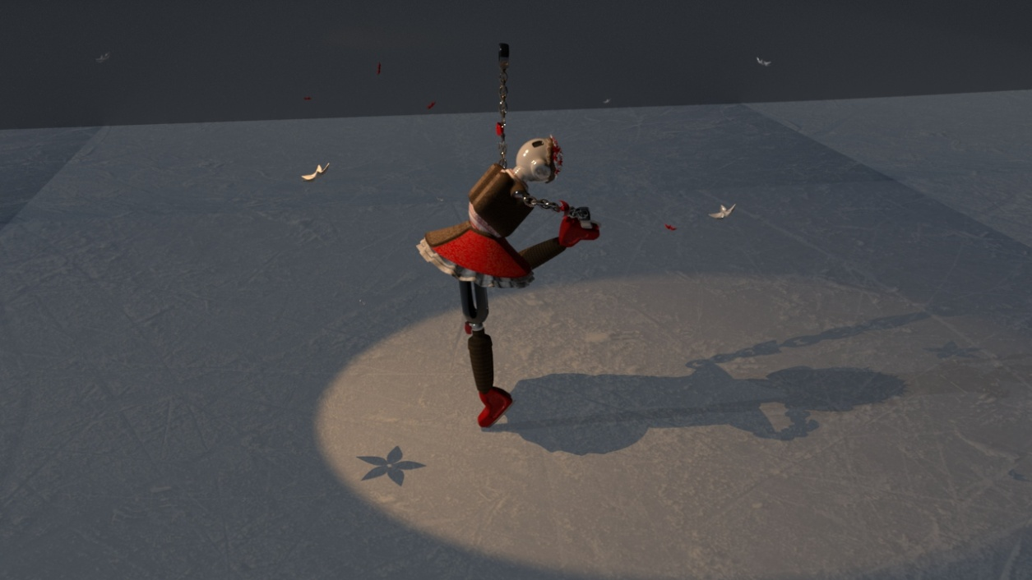

**Discussion and conclusion**

In conclusion, although I think I achieved my initial goal and managed to create the character the way I imagined it, I believe that I could have done a more complex design and added more details with the use of bump maps. A drawback in this part of the assignment has been my geometry. If I were to do this assignment again, I would model each part of the robot individually, for example having the apron and the skirt as two separate objects. This would have saved me time when assigning materials. I also would have liked to add more details to the geometry, such as having joints between the individual chains of the arm in order to make it clear that the robot can move its arms in many different ways. I would also remodel the upper half of the legs into something more complex and maybe use baked cloth for the clothing parts of my design.

For the second half of the assignment, I would have liked to experiment with the lighting more. I have tried to add a light fog to the spotlight, but it didn’t render properly, so given more time, I would like to fix that problem. I also would have liked to experiment with bump and reflection maps more.

To sum up, I am pleased with the character I created, but I would like to improve on a few aspects. The final rendered version can be seen in the image below. For the submitted version, I decided to edit the image in order to intensify the colours and add glow effects.

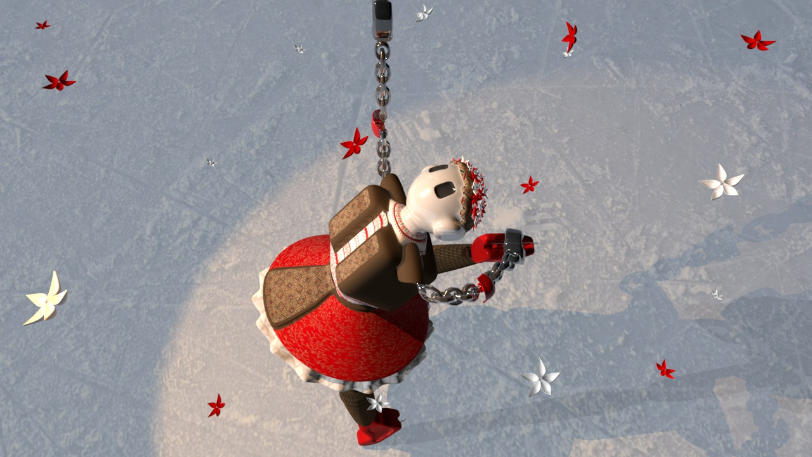

**Appendix**

